Platinum Jubilee Celebrations

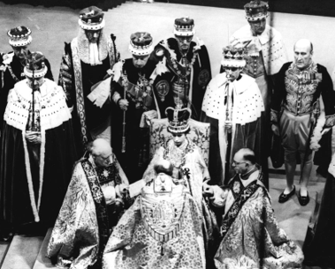
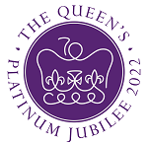
In 2022, Her Majesty The Queen will celebrate her Platinum Jubilee, seventy years after having acceded to the throne on 6th February 1952 when Her Majesty was 25 years old.

An extended bank holiday, from Thursday 2nd to Sunday 5th June, will provide an opportunity for communities and people throughout the United Kingdom to come together to celebrate this historic milestone.

The parish council would like to encourage people to give some ideas and suggestions as to how we can celebrate this momentous occasion in our village.

The National events include Trooping of the Colour and Beacon lighting (Thursday 2 June); a Service of Thanksgiving in St Paul’s Cathedral (Friday 3 June); Platinum Party at the Palace - The BBC will stage and broadcast a special live concert from Buckingham Palace (Saturday 4 June); The Big Jubilee Lunch (Sunday 5 June)

You can email any suggestions to us (see Contact page) or contact any councillor direct. You may even feel that a dedicated group should meet and decide the way forward. We are open to ANY suggestions.

Please support us for this historic occasion!

