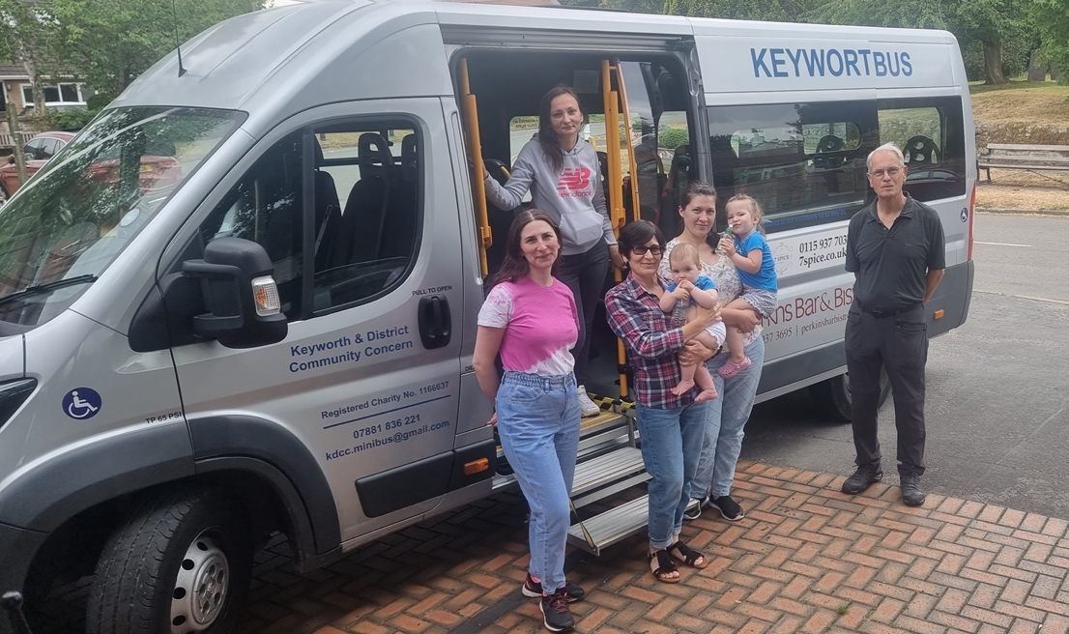

A number of families in Wysall are hosting under the Homes for Ukraine Scheme. The group meets regularly at the Village Hall on Wednesdays socially and to continue to improve their English language, which is clearly the most immediate requirement having secured safe passage to the UK and after successfully enrolling children in local schools.

The next big step is to enable our Ukrainian guests to gain wider independence outside of the village, which has fallen until now to respective hosts to manage. Keyworth Community Bus service is being offered to our needy group and initially we are envisaging regular trips to Keyworth Village Hall on Thursdays at approximately 6-9pm and then an alternate Tuesday and Saturday delivery and collection run to enable the group to go shopping and/or engage in other social activities in West Bridgford or Nottingham.

To be able to offer this service, we need volunteer drivers which would be willing to undergo a 1-hour familiarisation session and then be able to drive one of the 16-seater mini buses.

A number of individuals have contacted us previously to offer help with transport and we are now requiring a pool of drivers who would be willing to drive the mini-bus.

If you are interesting in helping this extremely worthwhile cause, please contact me as detailed below.

Tim Calnan
tim@calnan.co.uk
07909965065

Many thanks

Tim

