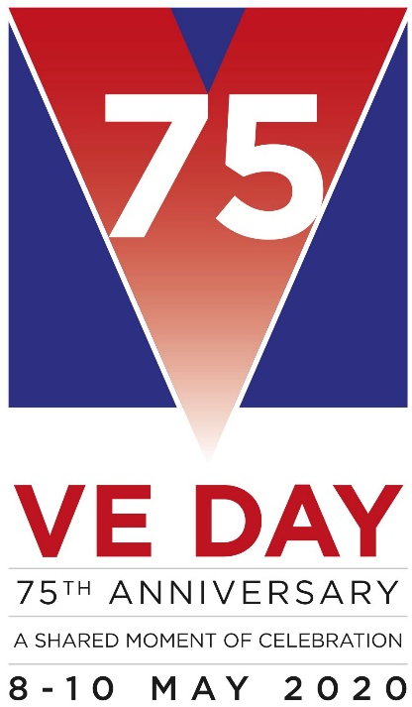
Wysall & THORPE IN THE GLEBE PARISH COUNCIL
(Rushcliffe Borough Council Nottinghamshire)
19/21 Main Street
Keyworth
Notts
NG12 5AA

Clerk to the Council:
MIKE ELLIOTT
Tel: 0115 937 6506
Email elliottnews@btconnect.com

MEETING NOTICE

THE next MEETING of the PARISH COUNCIL will be held on TUESDAY, FEBRUARY 4, 2020 at the Village Hall at 7.15 pm.

The agenda for the parish council meeting is as follows:

1] APOLOGIES
2] MINUTES FROM PREVIOUS MEETING HELD ON JANUARY 7, 2020
3] DECLARATIONS OF INTEREST
4] CLERK’S REPORT
5] OPEN SESSION FOR THE PUBLIC, LIMITED TO 15 MINUTES
6] REPORT FROM THE DISTRICT AND COUNTY COUNCIL MEMBER
7] CORRESPONDENCE
8] FINANCE
a] Accounts to pay
9] PLANNING MATTERS

10] VILLAGE HALL
11] ENVIRONMENTAL
Defibrillator.
12] WEBSITE

13] STANDING ORDERS. FINANCIAL REGULATIONS.
14] VE DAY 75

15] CHAIRMAN’S MATTERS
16] AGENDA ITEMS FOR NEXT MEETING MARCH 3, 2020

Mike Elliott, Clerk to the Parish Council.

January 28, 2020

