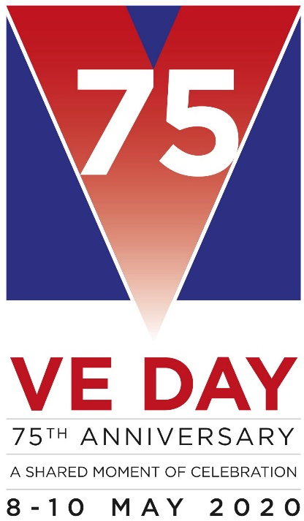
Wysall & THORPE IN THE GLEBE PARISH COUNCIL
(Rushcliffe Borough Council Nottinghamshire)
19/21 Main Street
Keyworth
Notts
NG12 5AA

Clerk to the Council:
MIKE ELLIOTT
Tel: 0115 937 6506
Email elliottnews@btconnect.com

MEETING NOTICE

THE next MEETING of the PARISH COUNCIL will be held on TUESDAY, NOVEMBER 5, 2019 at the Village Hall at 7.15 pm.

The agenda for the parish council meeting is as follows:

1] APOLOGIES
2] MINUTES FROM PREVIOUS MEETING HELD ON OCTOBER 1, 2019
3] DECLARATIONS OF INTEREST
4] CLERK’S REPORT
5] OPEN SESSION FOR THE PUBLIC, LIMITED TO 15 MINUTES
6] REPORT FROM THE DISTRICT AND COUNTY COUNCIL MEMBER
7] CORRESPONDENCE
8] FINANCE
a] Accounts to pay
b] Budget 2020-2021

9] PLANNING MATTERS

10] VILLAGE HALL
11] ENVIRONMENTAL
Defibrillator training.
12] WEBSITE

13] STANDING ORDERS. FINANCIAL REGULATIONS.
14] VE DAY 75

15] CHAIRMAN’S MATTERS
16] AGENDA ITEMS FOR NEXT MEETING DECEMBER 3 2019

Mike Elliott, Clerk to the Parish Council.

October 27 2019

