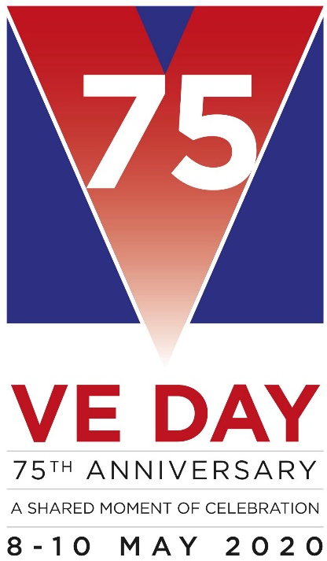
Wysall & THORPE IN THE GLEBE PARISH COUNCIL
(Rushcliffe Borough Council Nottinghamshire)
19/21 Main Street
Keyworth
Notts
NG12 5AA

Clerk to the Council:
MIKE ELLIOTT
Tel: 0115 937 6506
Email elliottnews@btconnect.com

MEETING NOTICE

THE next MEETING of the PARISH COUNCIL will be held on TUESDAY, SEPTEMBER 03 2019 at the Village Hall
at 7.15 pm.

The agenda for the parish council meeting is as follows:

1] APOLOGIES
2] MINUTES FROM PREVIOUS MEETING HELD ON JULY 2, 2019
3] DECLARATIONS OF INTEREST
4] CLERK’S REPORT
5] OPEN SESSION FOR THE PUBLIC, LIMITED TO 15 MINUTES
6] REPORT FROM THE DISTRICT AND COUNTY COUNCIL MEMBER
7] CORRESPONDENCE
8] FINANCE
a] ACCOUNTS TO PAY
Apply to East Midlands Airport Grant to pay for either/both of a new noticeboard/new nets for the mini football goals.
9] PLANNING MATTERS
10] VILLAGE HALL including heating of the premises and electricity supplier
11] ENVIRONMENTAL MATTERS including street furniture, Siting and buying a VE memorial bench for the grass on the opposite side of the road to the WW1 memorial.
Resisting the old/a new noticeboard on the northern corner of Main St and Widmerpool Rd.
No. 3 footpath
12] WEBSITE
13] STANDING ORDERS AND FINANCIAL REGULATIONS
14] CHAIRMAN’S MATTERS
15] AGENDA ITEMS FOR NEXT MEETING OCTOBER 01, 2019

Mike Elliott
Clerk to the Parish Council.
August 28, 2019

