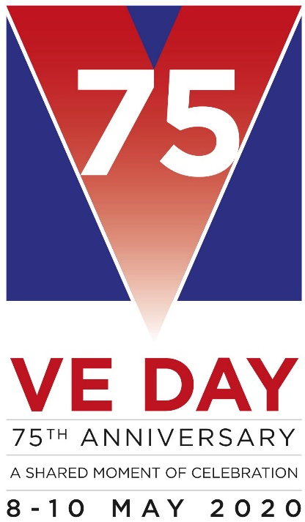
Wysall & THORPE IN THE GLEBE PARISH COUNCIL
(Rushcliffe Borough Council Nottinghamshire)
19/21 Main Street
Keyworth
Notts
NG12 5AA

Clerk to the Council:
MIKE ELLIOTT
Tel: 0115 937 6506
Email elliottnews@btconnect.com

MEETING NOTICE

THE next MEETING of the PARISH COUNCIL will be held on TUESDAY, June 4 2019 at the Village Hall at 7.15 pm.

The agenda for the parish council meeting is as follows:

1] APOLOGIES
2] MINUTES FROM PREVIOUS MEETING HELD ON MAY 7, 2019
3] DECLARATIONS OF INTEREST
4] CLERK’S REPORT
5] OPEN SESSION FOR THE PUBLIC, LIMITED TO 15 MINUTES
6] REPORT FROM THE DISTRICT AND COUNTY COUNCIL MEMBER
7] CORRESPONDENCE
8] FINANCE
a] ACCOUNTS TO PAY
9] PLANNING MATTERS
10] VILLAGE HALL including heating of the premises and electricity supplier
11] ENVIRONMENTAL MATTERS including street furniture
12] WEBSITE
13] CHAIRMAN’S MATTERS
14] AGENDA ITEMS FOR NEXT MEETING JULY 2, 2019

Mike Elliott
Clerk to the Parish Council.
May 29 2019

