wysall and Thorpe in the
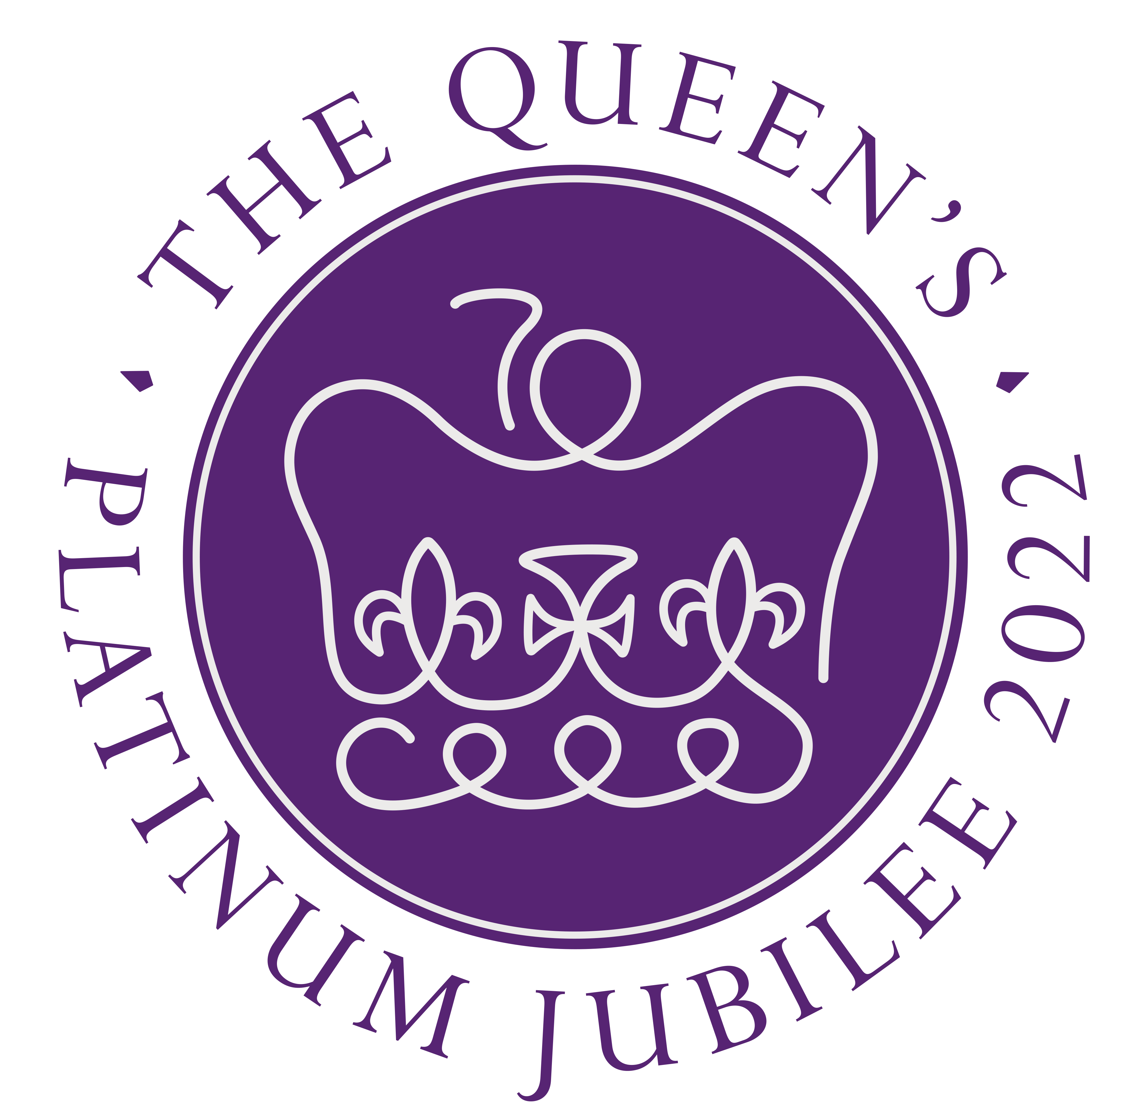
June 2,3,4,5

glebe Parish Council
(Rushcliffe Borough Council, Nottinghamshire)

19/21 Main Street
Keyworth
Notts
NG12 5AA

Clerk to the Council:
MIKE ELLIOTT
Tel: 0115 937 6506
Email clerk@wysall.parish.email

The next meeting of the parish council will be held on Tuesday, March 1, 2022 at 7.15pm prompt and be held in the Village Hall, Wysall. Members of the public are welcome to attend to listen to the proceedings or take part in Item 7.

The agenda is:
1] Apologies
2] Minutes from Previous Meeting held on February 11, 2022
3] Declarations of Interest
4] Clerks Report
5] HM Queen 70th year Reign June 2,3,4 and 5,
6] Report from the District and County Council Member
7] Items by members of the public (limited strictly to 15 mins)
8] Village Hall
9] Accounts to pay
10] Correspondence
11] Planning
12] Environment
13] Playground equipment project,
14] Next meeting April 5, 2022

Mike Elliott
Clerk

